WEEK NUMBER: |  | 7
STUDENT NAME: |  | Anas Al Azad
STUDENT ID: |  | 105694136
WEEK # | 7
Dates covered: | 21-27 September 2026
Lab tasks | What I did |  | TIME SPENT | Learning & Problems
Neural network fundamentals  Lab sheet section 2, nn_experiments.ipynb part A | - Went through layers, neurons, weights & bias, z = Σ(w·x) + b, activation functions, loss functions (MSE, MAE, binary/categorical cross-entropy), backprop and gradient descent.  - Plotted sigmoid / tanh / ReLU and tried softmax on [2, 1, 0.1] → [0.659, 0.242, 0.099] (Fig 7.1).  - Trained one neuron by hand in numpy on the AND gate: forward pass → binary cross-entropy → backprop → gradient descent. Loss 0.694 → 0.0087, weights [8.82, 8.82], bias −13.4, predicts [0, 0, 0, 1] ✔. |  | 1.5 h | Learning:  - Without a non-linear activation the whole network is just one linear function.  - Sigmoid/tanh go flat at the ends (tiny gradients) → ReLU for hidden layers, softmax for the multi-class output.  - For sigmoid + cross-entropy the backprop gradient simplifies to (a − y).  Problems:  - None really for this one.
MNIST neural network  neural_net.ipynb | - MNIST: 60,000 train / 10,000 test images, 28×28, pixels 0–255 → scaled to 0–1 and flattened to 784.  - Network 784 → 32 → 64 → 10 (ReLU, softmax), SGD + sparse_categorical_crossentropy, 5 epochs: train acc 93.8%, test acc 93.80%, test loss 0.2045 (tutor's run: 93.87%).  - Prediction for x_test[45]: 5 with 93.8% probability (correct).  - Added tf.keras.utils.set_random_seed(42) so my results are reproducible. |  | 1 h | Learning:  - sparse_categorical_crossentropy = integer labels, categorical_crossentropy = one-hot labels.  - Scaling inputs to 0–1 helps gradient descent converge.  - The output is 10 probabilities – np.argmax picks the digit.  Problems:  - The provided code crashes on current TensorFlow (Keras 3): InputLayer(input_shape=28*28) → *ValueError: Cannot convert '784' to a shape*. Fixed with InputLayer(shape=(28*28,)) (input_shape is deprecated and it has to be a tuple). Fixed the same line in neural_net.py.  - The comments say 64 / 128 units but the code actually uses 32 / 64.
Extra – hyperparameter experiments  nn_experiments.ipynb parts B–C | - The notebook says to try combinations, so I ran 8 configs (same seed, 10% of the training set held out for validation) (Fig 7.2, 7.3):  - Adam 96.8% vs SGD 93.8% with the same network; SGD with lr = 0.1 → 96.5%; sigmoid instead of ReLU → only 76.6%; batch size 256 → 87.8%; best = Adam, 256-128, 10 epochs → 97.25%.  - Confusion matrix of the best model: most mix-ups are 2→3, 4→9, 7→3, 9→8; plotted some wrong digits – mostly messy ones (Fig 7.4, 7.5). |  | 2 h | Learning:  - Optimiser / learning rate made the biggest difference, then size + epochs.  - Bigger batch = fewer weight updates per epoch, so it needs more epochs.  - The biggest model's validation loss starts going back up around epoch 9–10 while training loss keeps falling → overfitting.  Problems:  - Every run takes 15–60 s on CPU (no GPU), so I kept it to 8 experiments instead of a full grid search.
Extra – PyTorch version  nn_pytorch.ipynb | - Rebuilt the network (784 → 128 → 64 → 10) in PyTorch with my own training loop: zero_grad → forward → loss → backward → step.  - Adam, 5 epochs: 97.6% test accuracy in 18 s on CPU – about the same as Keras. |  | 1 h | Learning:  - Keras hides the loop in fit(), PyTorch makes you write it – more code but you see every step from the lab sheet.  - nn.CrossEntropyLoss already includes the softmax, so no softmax layer at the end.  Problems:  - Running TensorFlow training and PyTorch training in the same Jupyter kernel crashed it (segfault – the two libraries clash). Moved PyTorch into its own notebook and loaded MNIST straight from the .npz file with numpy so it doesn't need TensorFlow.
TOTAL TIME THIS WEEK |  |  | 6.5 h

Screenshots:
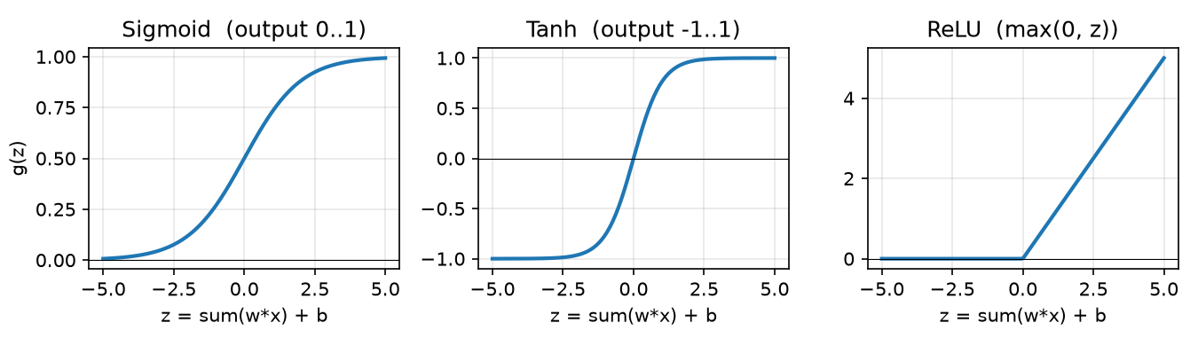
Figure 7.1 – the activation functions from the lab sheet
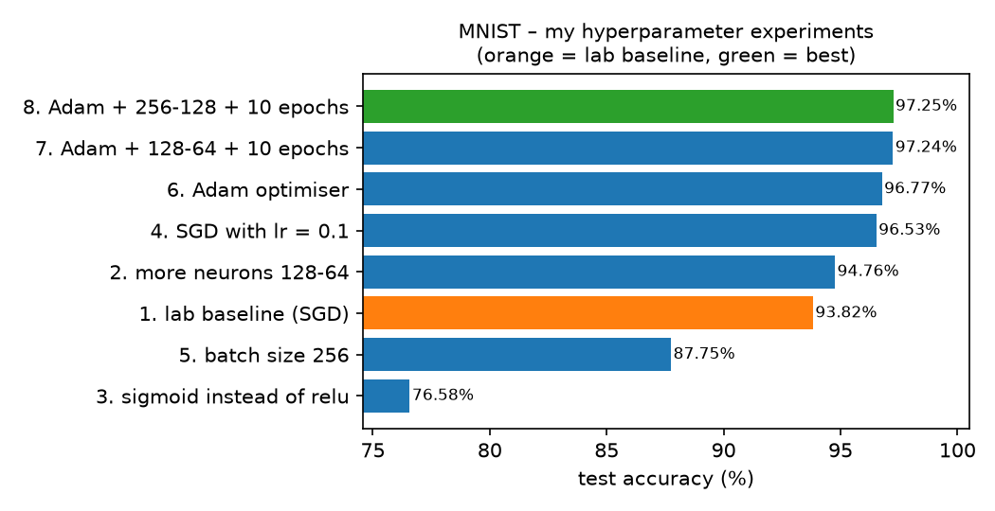
Figure 7.2 – test accuracy of my 8 hyperparameter experiments (orange = lab baseline, green = best)
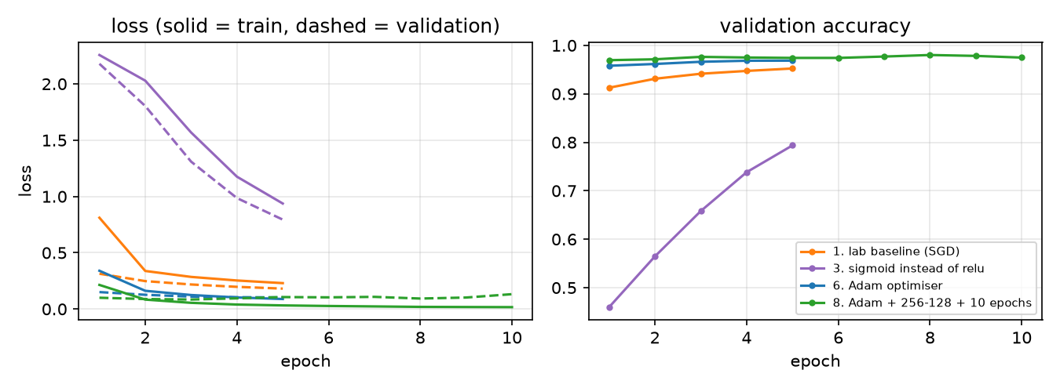
Figure 7.3 – learning curves – sigmoid learns slowly, Adam is fastest, the biggest model starts overfitting at the end
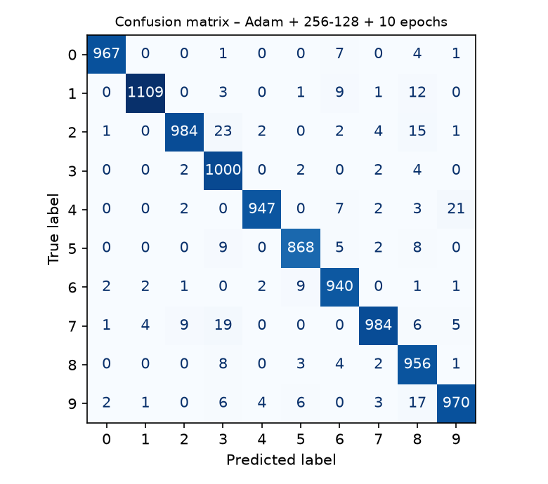
Figure 7.4 – confusion matrix of my best model (97.25% test accuracy)
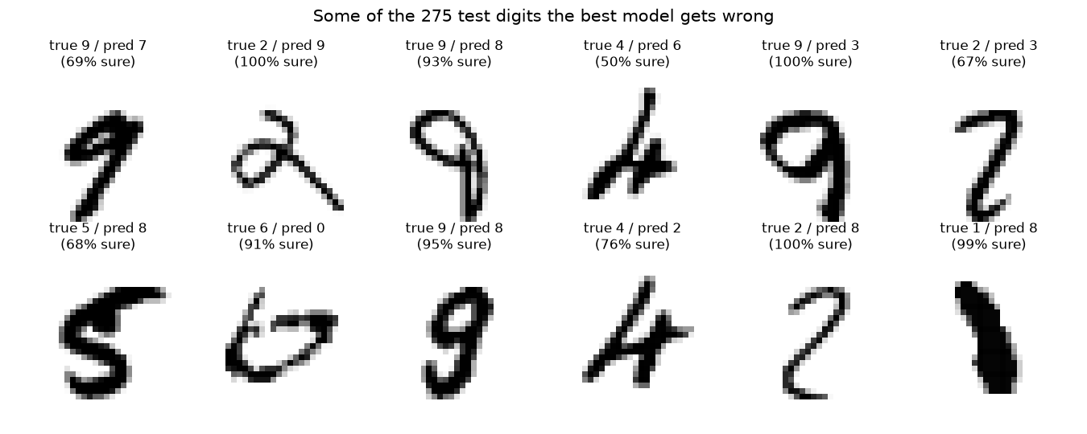
Figure 7.5 – some of the test digits my best model gets wrong
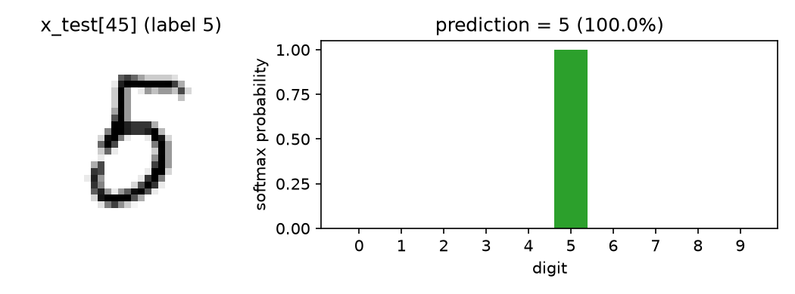
Figure 7.6 – the notebook's example digit x_test[45] and my best model's softmax output
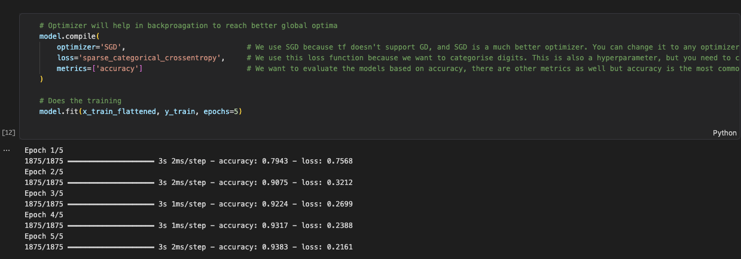
Screenshot 7.1 – neural_net.ipynb – model + training
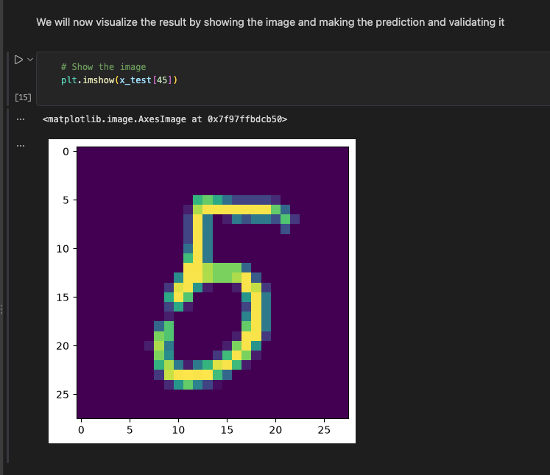
Screenshot 7.2 – neural_net.ipynb – test accuracy + prediction
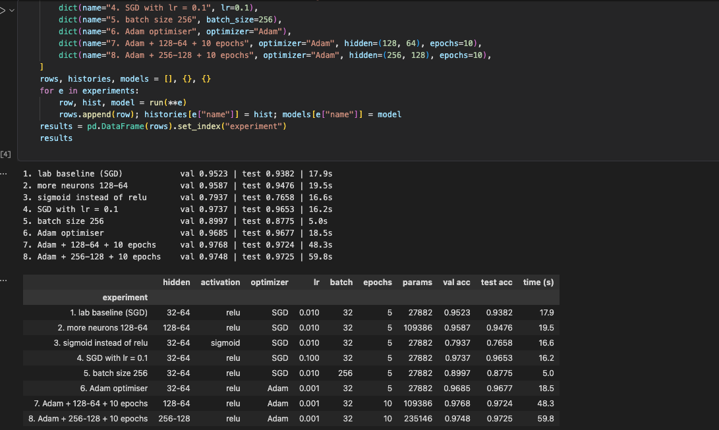Screenshot 7.3 – nn_experiments.ipynb – my experiment results
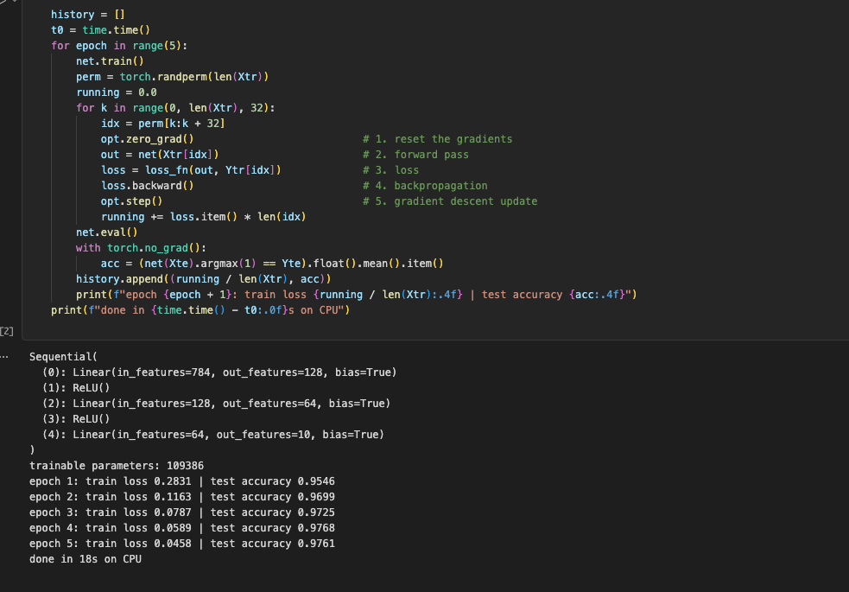Screenshot 7.4 – nn_pytorch.ipynb – PyTorch training

